**Lab Report 06**

In this lab, we are supposed to write a program that will use a height inputted by the user to draw a triangle on the screen, represented by asterisks.

To do this, I propose a for statement to draw a certain number of asterisks on each line, which will increment by one each time the loop repeats until the top of the triangle is reached. Then, the number of asterisks will decrement until no more will be drawn on a line.

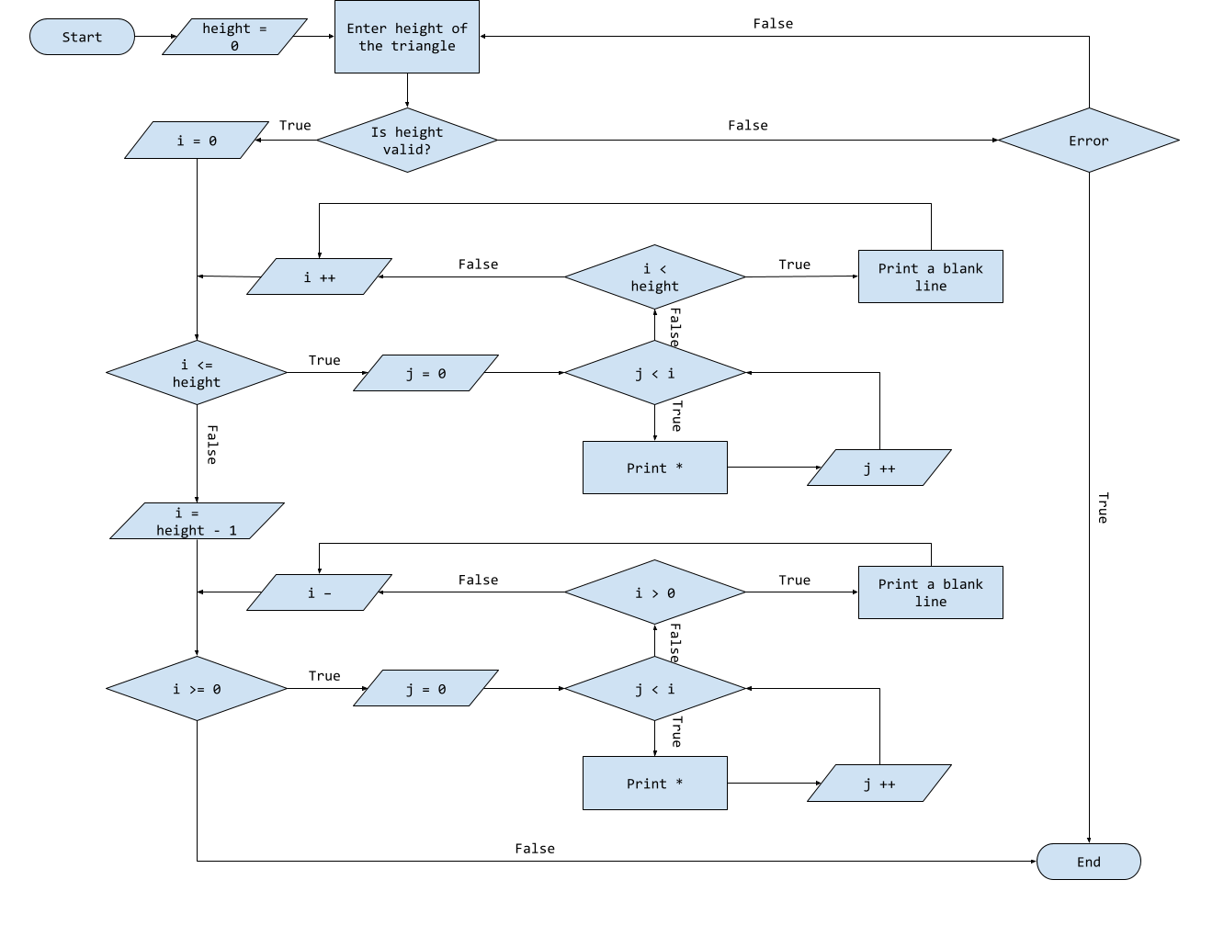

For this instance, a horizontal triangle was correctly displayed on the screen because a valid number was input by the user

For this instance, however, the user input loops because a non-positive integer was input by the user. The input statement loops until a positive integer is input into the program.

In this final instance, the program stops because a non-numeric characters was input by the user, which is not valid.

This lab served as good practice for utilizing for-loops within my programs. Coding it helped me familiarize with its parameters and how to get it to loop how I want it to.

Additional Questions:

1. Write a for statement to compute the sum of

1 + 22 + 32 + 42 + 52 +……+ *n*2

1. Define scope of a variable? Why is it important when a variable is declared in a loop? A variable is only valid in the loop in which it is defined. If it is defined outside of a loop, it is valid throughout the entire program
2. Does the code snippet below give an error? Why or why not?

for (int x = 0; x < 50; x ++)

{

System.out.println(x);

}

int y = x + 9;

The code will produce an error because x is not defined outside of the scope of the for-loop

1. Does the code snippet below give an error? If yes, rewrite the correct the code. Otherwise display the output.

for (int i = 0, j = 1; i < 3, j > 5; i ++, j ++)

{

System.out.println(i + j);

}

for (int i = 0; i < 3 || j < 5; i ++, j ++)

{

System.*out*.println(i + j);

}